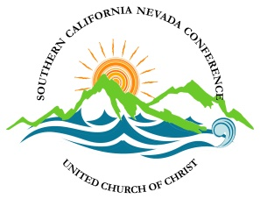
RESOLUTION REGARDING THE FILLING OF THE POSITION OF MODERATOR FOR THE 2020-2021 TERM.

Submitted to the SCNC Board of Directors from the Conference Staff for Consideration at the May 9, 2020 meeting of the Board.

BACKGROUND
The SCNC bylaws establish that the officers of the Conference be: Moderator, Vice Moderator, Secretary, Treasurer, Chair of the Board and Vice Chair of the Board. The bylaws do not prohibit one person filling more than one role. Each Conference of the United Church of Christ is self-governing, and a variety of models for the makeup of the respective Boards of Directors are employed, including a model in which the chair of the board acts as the moderator of the Conference’s annual business meeting.

The 2020 Nominating Committee, extremely diligent in their work, submitted for consideration a nominee for the position of Moderator who withdrew their name.

THE RESOLUTION
WHEREAS the nominee selected by the Nominating Committee for the position of Moderator has withdrawn their name, and,

WHEREAS the bylaws of the SCNC do not prohibit one person from holding more than one position on the Board of Directors, and

WHEREAS the bylaws of the SCNC require the slate of nominees be submitted to the Board of Directors no fewer than thirty days prior to the Annual Meeting and make no provision for nominations from the floor,

THEREFORE LET IT BE RESOLVED that the Board of Directors of the Southern California Nevada Conference of the United Church of Christ supports and approves the nomination and election of a single individual to the positions of Moderator and Chair of the Board of Directors for the 2020-2021 term.

LET IT BE FURTHER RESOLVED that at the 2021 Annual Gathering a person other than Moderator or Vice Moderator may assist in the running of the Business Meeting, if so requested and directed by the Moderator,

