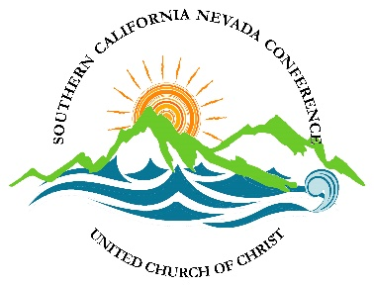
Southern California Nevada Conference
United Church of Christ
===============================================================

SPECIAL STANDING RULES FOR VIRTUAL ANNUAL GATHERING 2020
Saturday, June 13,2020

CONDUCT OF THE MEETING
The official program, as adopted, shall be the orders of the day.
The meeting shall be conducted online using the Zoom platform.
The proceedings of this meeting shall be recorded.
CREDENTIALS
For admission to the virtual meeting, all participants will be required to be registered. Delegates must be registered as such to vote.
Credentials are not transferable.
Should a delegate be absent or unable to serve, an alternate from the same Church may assume the duties of delegate for the remainder of the meeting, following certification by the Moderator.
MOTIONS
All motions shall be submitted in writing to the Moderator and the meeting clerk at the time they are made using the “chat” function in Zoom. Motion forms will be made available in the pre-meeting information.
Only delegates may make motions.
DEBATE
Both delegates and non-voting members shall be accorded the privilege of the floor. Precedence shall be accorded delegates.
To obtain the floor, the speaker shall use the raise hand facility provided in the Zoom platform, and having been recognized, address the Moderator, and state the speaker’s name and Church.
No delegate may speak in debate more than twice nor longer than 2 minutes on the same question except by consent of 2/3 of the voting delegates.
A non-delegate may only speak to a question and only for 2 minutes providing no delegate wishes to speak.
An extension of time may be granted by the Moderator to the following persons:
A. Speakers requiring translation into English from another language (time needed for the translation shall not be counted in the time allotment) and speakers who require sign language translation;
B. Speakers whose fluency in English is limited and for whom translation is not available;
C. Speakers with disabilities which affect mobility and/or speech.
An official timekeeper shall call time on debate.
RESOLUTIONS
A brief time, not to exceed fifteen (15) minutes will be allotted for debate and vote on each resolution. Any resolution which does not meet the requirements set forth in the pre-Gathering communication will not be considered by the Meeting, and will be referred to the Board of Directors.
VOTING
Voting shall be accomplished through the facility provided in the Zoom platform, or similar modality as approved by the Board of Directors. In the event that voting in this manner is deemed unwise for a particular matter before the assembly, votes will be cast by mail, using ballots provided by the Conference for that purpose.
REPORTS
All reports and other materials for the permanent record shall be submitted to the Moderator or Conference Communications Consultant in advance in digital form.
DECORUM
Please be logged in and ready for the opening the session.
Please mute yourself unless recognized by the Chair.
The chair shall be addressed as Moderator.

